Using Ai to Simulate and Create an Optimal Racing Lap Time

# Link to Repo on GitHub

<https://github.com/trapperrnz/mychrontoios>

Project Management Tools

# **Notion**

Notion is a widely used project management tool that integrates the use of boards, lists and cards to help users prioritise and effectively manage their workloads. In my case it is extremely effective for breaking down complex projects into manageable tasks, with the ability to track and tick off my progress in real time.

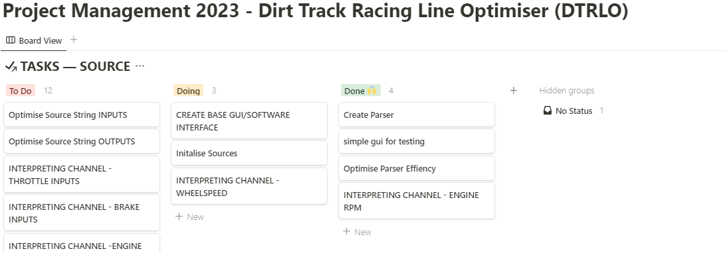

# **Creating Goals and Milestones**

Evidence and Testing

# **Video Evidence**

[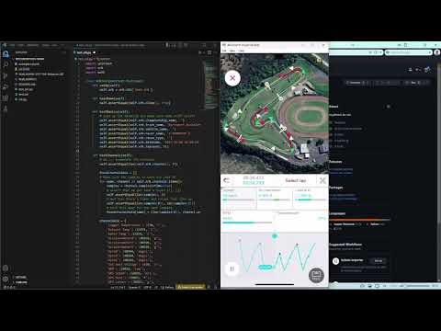](https://www.youtube.com/embed/GFj565m1YZc?feature=oembed)

# **Photo Evidence**

# **Testing Log**

[Testiing Log 2023 MYCHRON TO IOS.docx](https://1drv.ms/w/s!AmwzA2TiNJJxokbGasVDydypiWpI?e=uCp1UK)